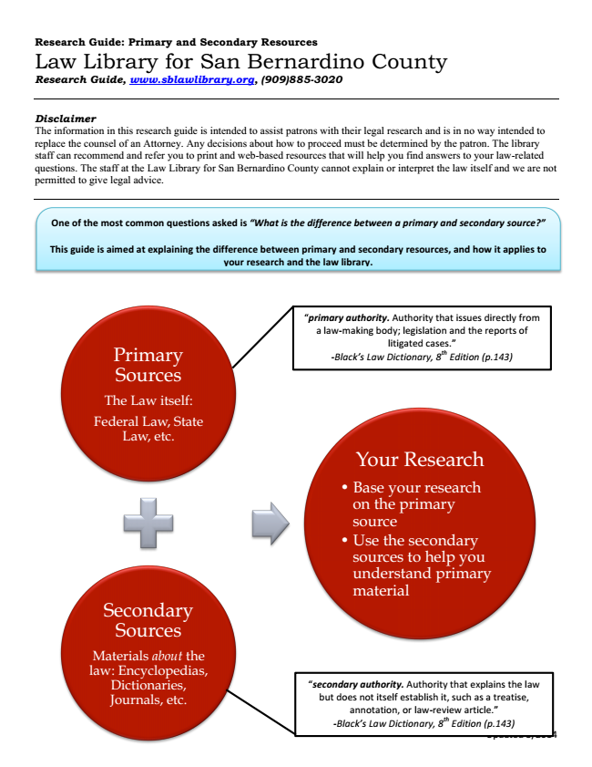
Research Guide: Primary and Secondary Resources Law Library for San Bernardino

